# Introduction to OSINT

## What is OSINT – open source intelligence?

For normal information gathering purposes, or even research, people usually access the search through Google or other similar search engines. In this respect, it must be noted that such search engines only have access to the outer periphery of the internet, AKA the surface web. Also, it is the set of algorithms implemented by such engines which rank and display pages as per their convenience, thus trading in a lot of control.

Essentially, OSINT (Open Source Intelligence) is the concept, by implementation of which, one can access the vast pool of data just lying there out in the internet, to be accessed. It can be used to build specific profiles on entities, peoples, organisations, etc. Also, it is to be noted that search engines provide you with third-party data, whereas we are primarily interested in primary data.

Most of the data available is found in databases of various servers, which can be accessed by certain specific APIs. The functioning of any organisation generates data and produces paper trails (which are used to trace back and link several entities which, in an on-the-face, might seem completely disconnected from one another. People in general, contribute to a lot of data regarding themselves on social media sites as well as others, which can be further accessed by APIs. In this way, the vast pools of data can be mined, analysed and given forms of mathematical relationships, not immediately obvious to a human researcher.

It finds its primary usage in three primary fields:

* Business intelligence
* Civil intelligence
* Military intelligence

## Reconnaissance

Reconnaissance is defined by the Cambridge English Dictionary as –

“**the process of getting information about enemy forces or positions by sending out small groups of soldiers or by using aircraft, etc.”**

However, it is to be kept in mind, that although introduced to language as a military term, as the precedence of the cyber increases of the humane, it has found a more general meaning in our modern times -   
  
A survey or study of any entity to gather further information about the same, which might not be available just by making simple preliminary observations.

In terms of OSINT, however, it means surveying our target and identifying key points about it. For example, if we are researching for a certain business organisation and offering cyber espionage missions to survey the technologies used by their competitors, we would first require access to the competitor’s systems. For this, we do our research on their cyber entry points and employees and check for weak links.   
  
In this regard, it is to be kept in mind that – “a chain is as strong as its weakest link” has never acquired more importance than the present times.

In this stage, we look for the weakest points for our entry point attacks, such as suppose – one of the employees had their account compromised in some entirely different setting, and some disjoint service. It is noted such that their user ids and passwords are primarily trivial, if not anything else. By the basic proponents of social engineering, we can state that, as humans are creatures of habits, it is highly likely that they probably use the same passwords in most of their other accounts, as is more common than any of us can imagine. Now, the task of identifying the user id for their account is only a few key strokes away.

Thus, without much expense of either time or computational power, we can easily compromise their data and have access to whatever is available to the compromised account’s privilege level.

This pattern of attack is also known as “IDENTIFYING THE LOW HANGING FRUIT” – which basically means maximising results while ensuring minimal effort.

## Intelligence cycle

Collation, validation and evaluation of the collected data and information to confirm its usefulness and relevance.

In the right format, to the right hands, through the right medium.

Key components are relevance, accuracy, and completeness in satisfying original requirements.

Analysis and Production

Dissemination

and Feedback

Processing

Helps determine where and how to conduct data acquisition and information gathering.

Collection

Critical to the success of any intelligence program.

Planning and Direction

The purpose of intelligence gathering is to refine raw data into insight and understanding through answering questions in an investigation. An important note here is the fact that **data** in itself is not **intelligence**. For intelligence need to be actionable, which can only be done by proper processing of the collected data. Data can be mined by anybody, but it takes an efficient analyst to give it the proper shape that is desired out of it.

We aim to accomplish this by gathering data to build a complete picture allowing us to arrive at specific conclusions. By representing data in a graph model, we can see patterns through link analysis.

Link analysis is a type of knowledge discovery. It is an iterative user-interactive process used to spot, attempt to analyse, and clearly visualize patterns in datasets. Feeding bad or irrelevant data into link analysis makes it useless.

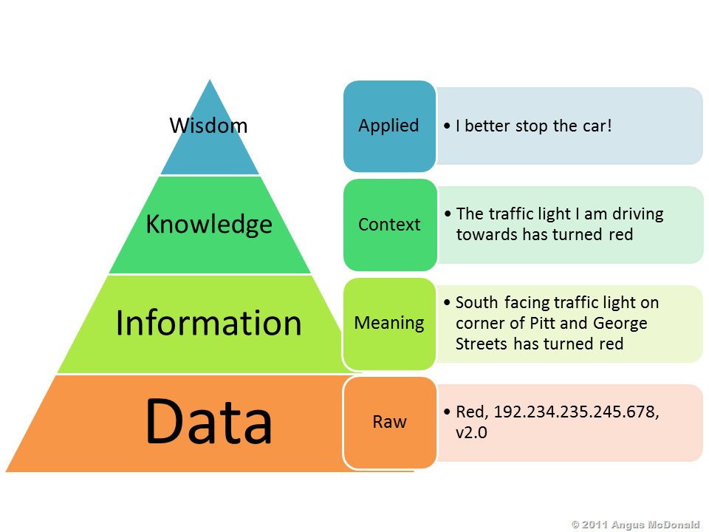

# Maltego

## Introduction

The goal of investigation with Maltego is to refine raw data into intelligence. It defines all the collated data using a very easy to use Graphic User Interface.

It is used via inputting certain data in form of entities and by implementing several pre-defined algorithms, known in this respect as “transformations” to mine further data. All further processing of data input, refinement, transformation, analysis and visualisation is taken care of it by a simple click.

It collects data from a vast number of APIs to be able to search for patterns and clearly display them. Commercial partners develop transforms for investigators, police, military and intelligence agencies. Particular focus is given on social media and technical infrastructure, tracking of people, organisations and physical hardware.

## Operational Walkthrough

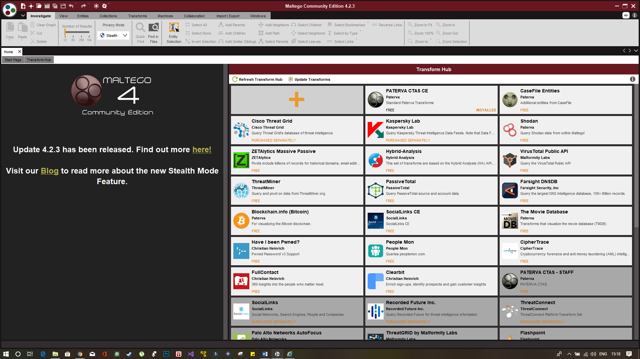

Above is the home screen of Maltego (Community Edition) which offers you an insight of the various options available in front of you, as well as the various transformation algorithms available. You may opt to install the additional transformation algorithms by simply clicking on the install button as shown below and follow through with the incredibly simple procedure that follows. You might be required to provide the API keys offered by the services by registering separately in their home sites.

(In the example is shown the details for installing the Shodan API)

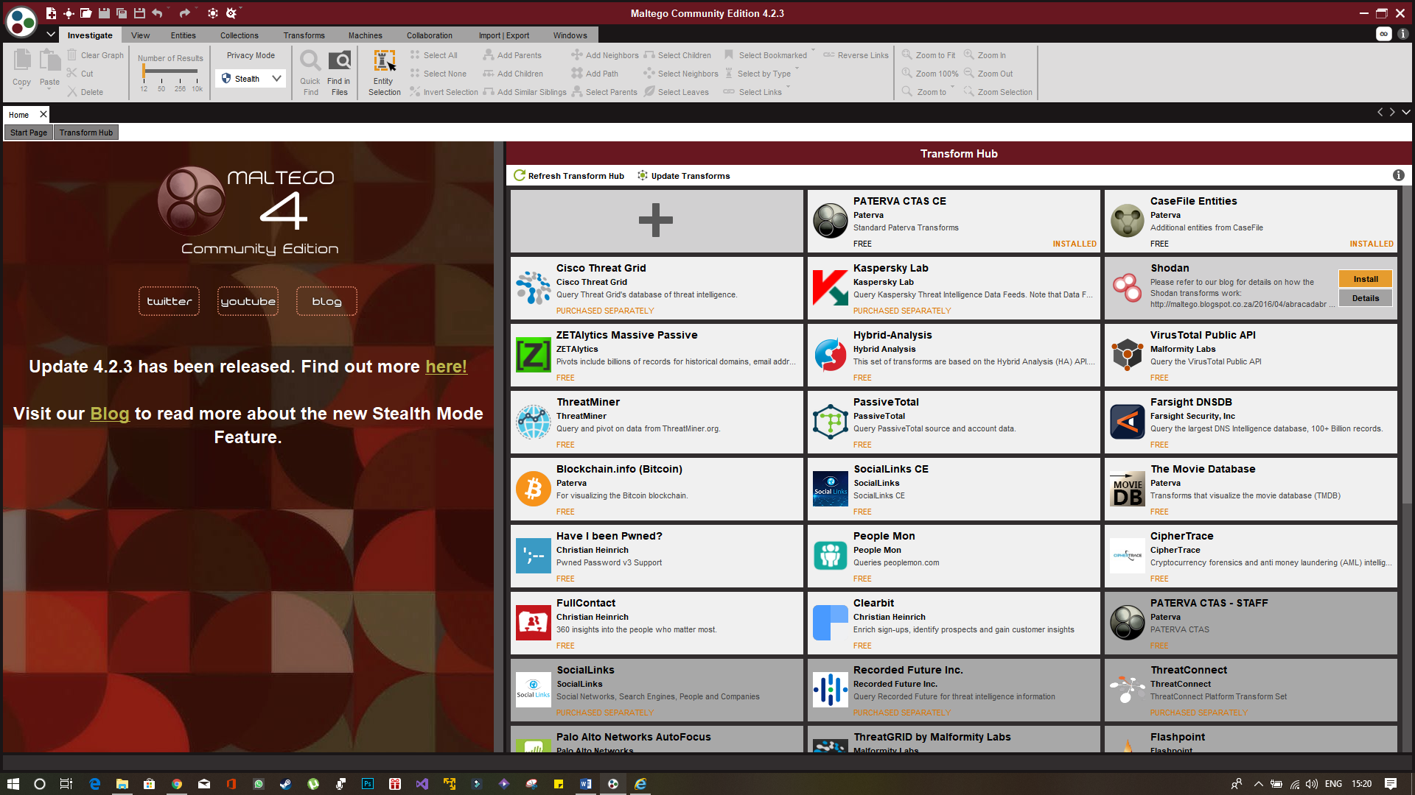

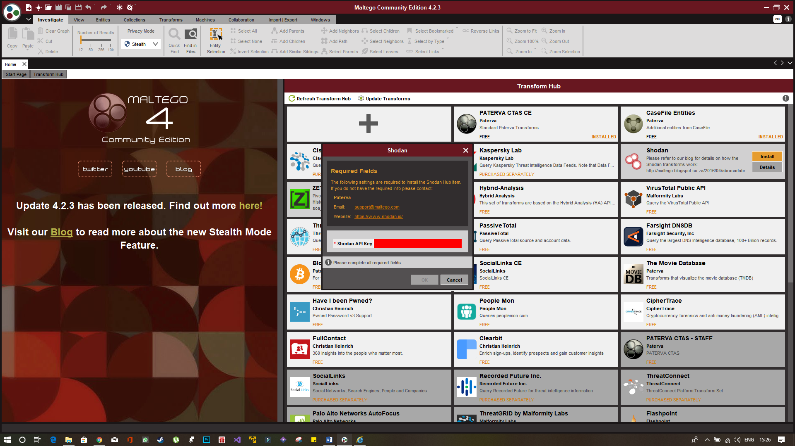

However, there are some commercial transformations that are to be paid for seperately, which provides you with their API keys, which you must provide the software with, such that they may access the data offered by the same.

The following shows the New Graph button which can be clicked to open an empty graph canvas which will later on show all the data mined as per the user’s iput. The hotkeys are : Ctrl+T or Cmd+T.

(It is advised however, to have as many installed transformations as possible, to give you the maximum data mined, as possible.)

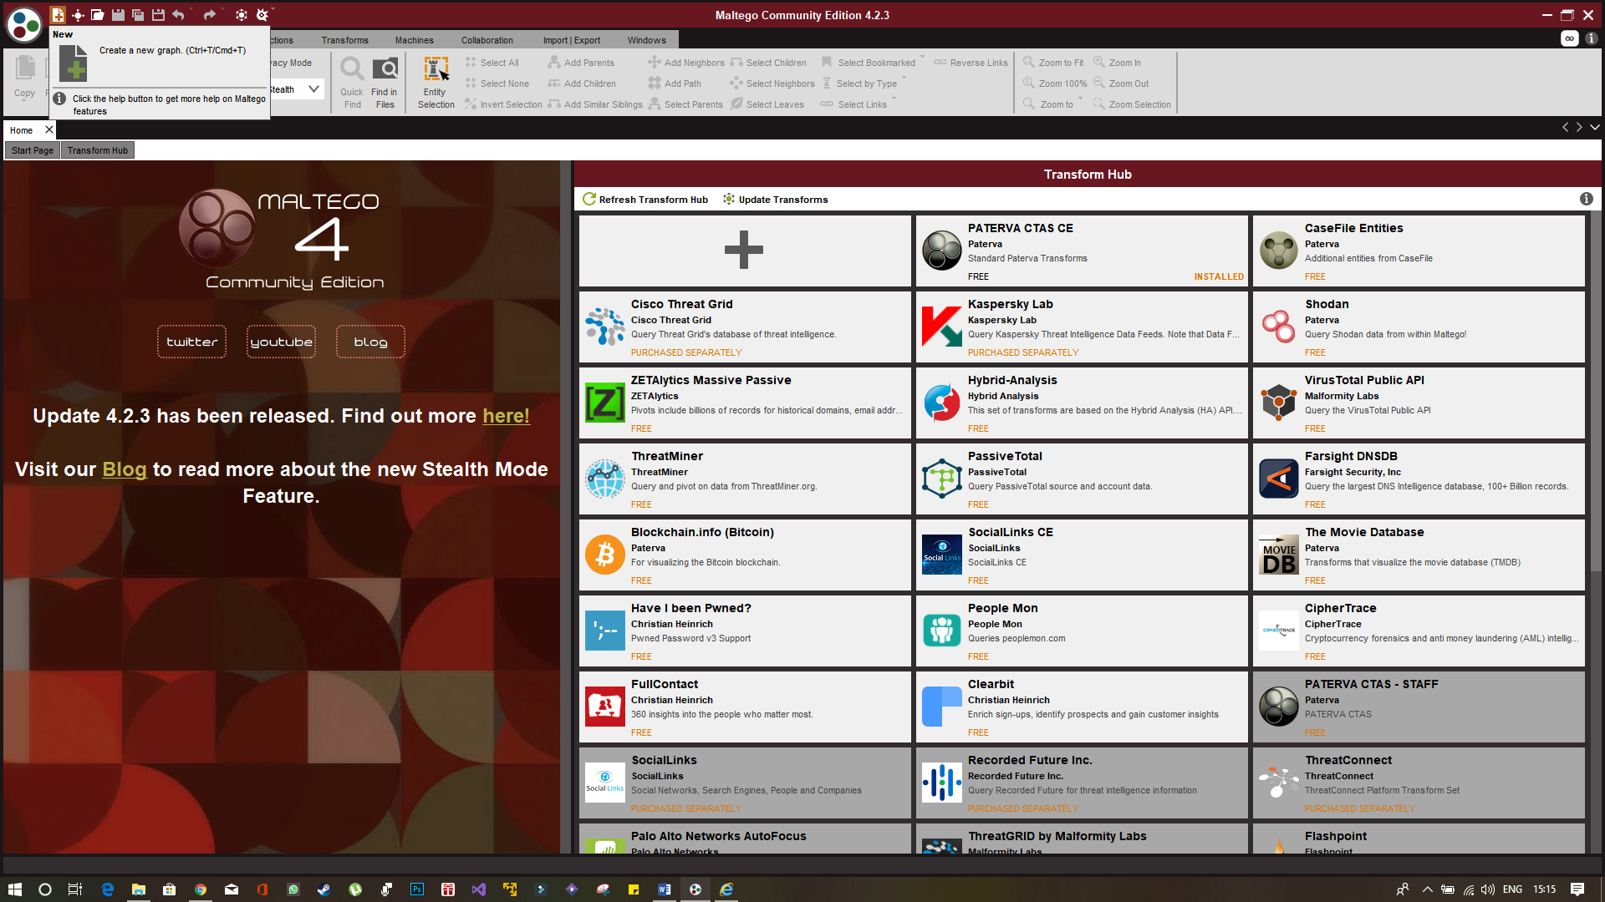

To introduce a new element in the graph, simply select the entity type in the left-hand menu of Entity Palette and drag it into the white blank space as follows. (The example shows a domain entity being dragged into the graph.)



We can simply click on the link to give it the desired value. For our purpose, let us go with [www.sony.com](http://www.sony.com).

Now, if we right click on the node, we get the following menu (with a list of all the transformation submenus installed in the system).

We can either be selective and open the submenus and select a particular transform, or go ahead and run an entire arsenal of transforms available under a certain installed transformation set, or for a general, more profound, mining, we can just go ahead with All Transformations.

One note in this regard, while you open the submenus and see that to implement a singular transformation, we have a play button, for the implementation of a submenu, we are to click on the double-play of fast-forward button.

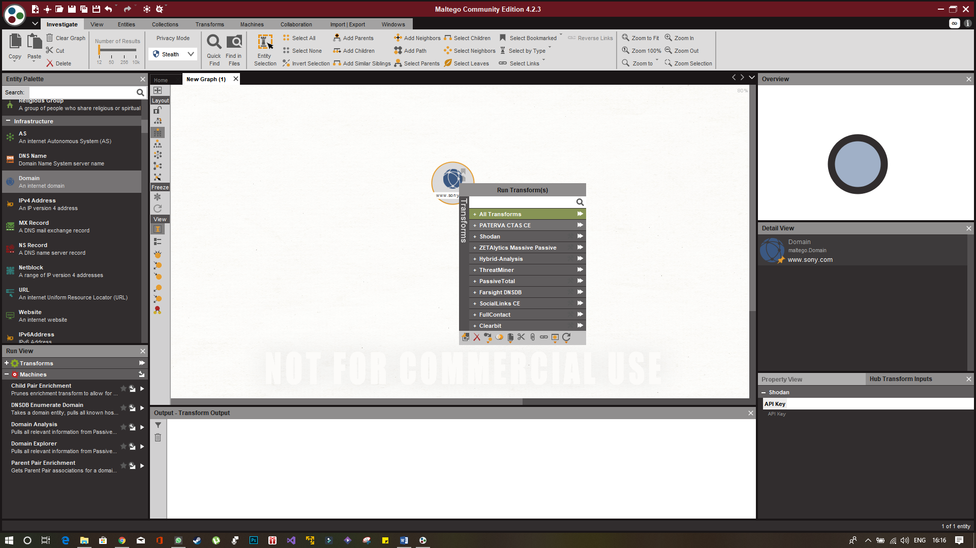

Now as we go ahead, we get the returned map as something like this:

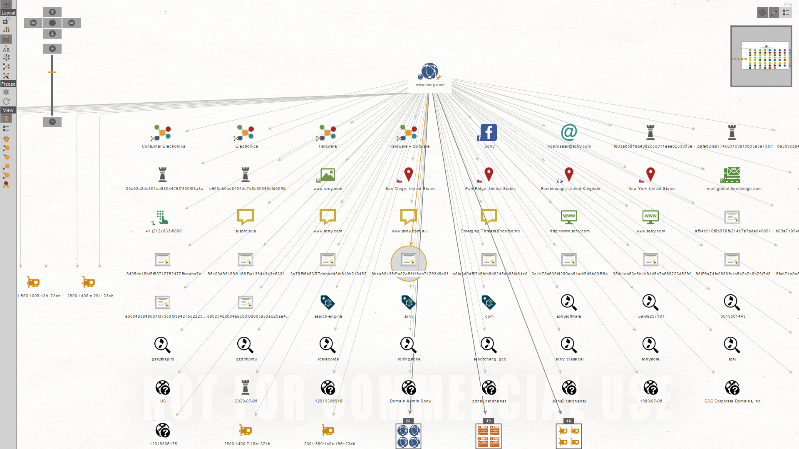

Now suppose we get nodes, as follows, which are of no substantial use to us, we can simply drag and select and press on DEL to delete these unwanted nodes from our graph:

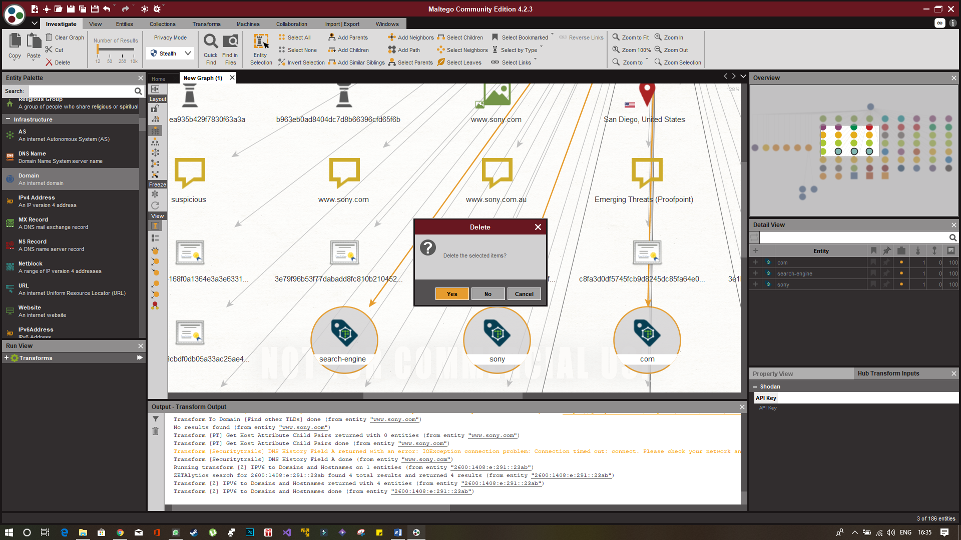

We can also change the type of view we are seeing, by the left side menu panel as shown below:



Now for further investigation of a certain node, all we have to do is right click on that node and run desired transforms again and analyse the new connected nodes in the map.

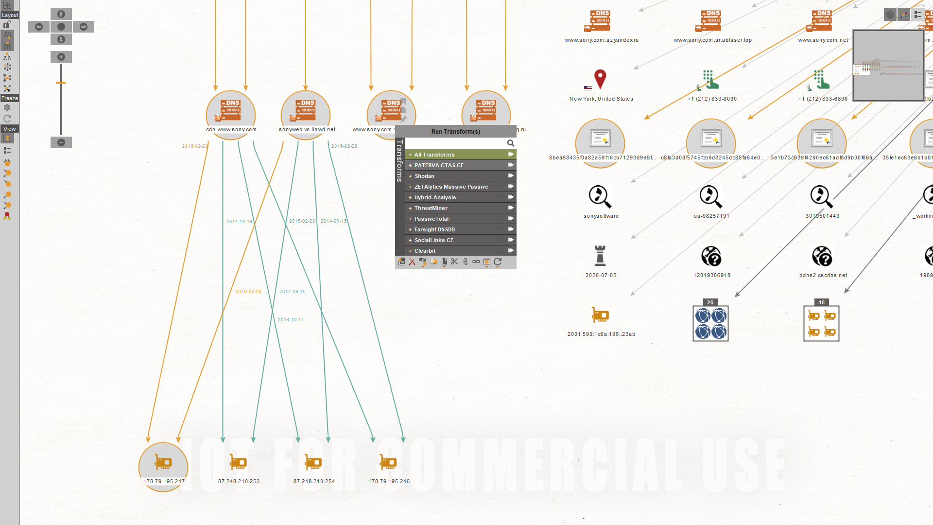

As you can see, if two separate nodes provide the same new nodes upon analysis, the new node is mapped in a many-to-one relationship.

## Linked Analysis Example

In this example, we take a relatively simpler entity for effective documentation of the analysis.

We are taking the domain <https://dfir.science/> for this purpose.

After running all transformations available at our disposal, we get the following graph available at our disposal:

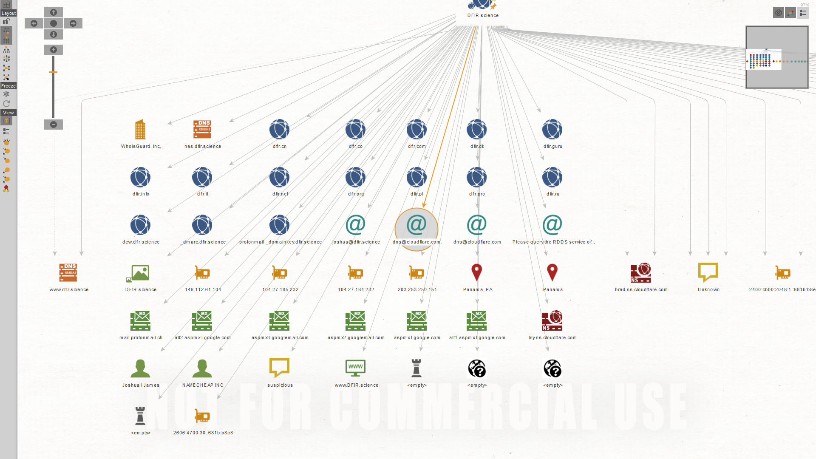

**Now we can see that the target domain is protected by cloudflare services. However, we also get access to certain email address which looks valid and the handler’s contact Joshua I James (possible because his PGP – Pretty Good Privacy key is public) and certain IP addresses, which we might further examine. We also see that the domain probably uses NAMECHEAP Inc’s services in site hosting and the geological location is masked.**

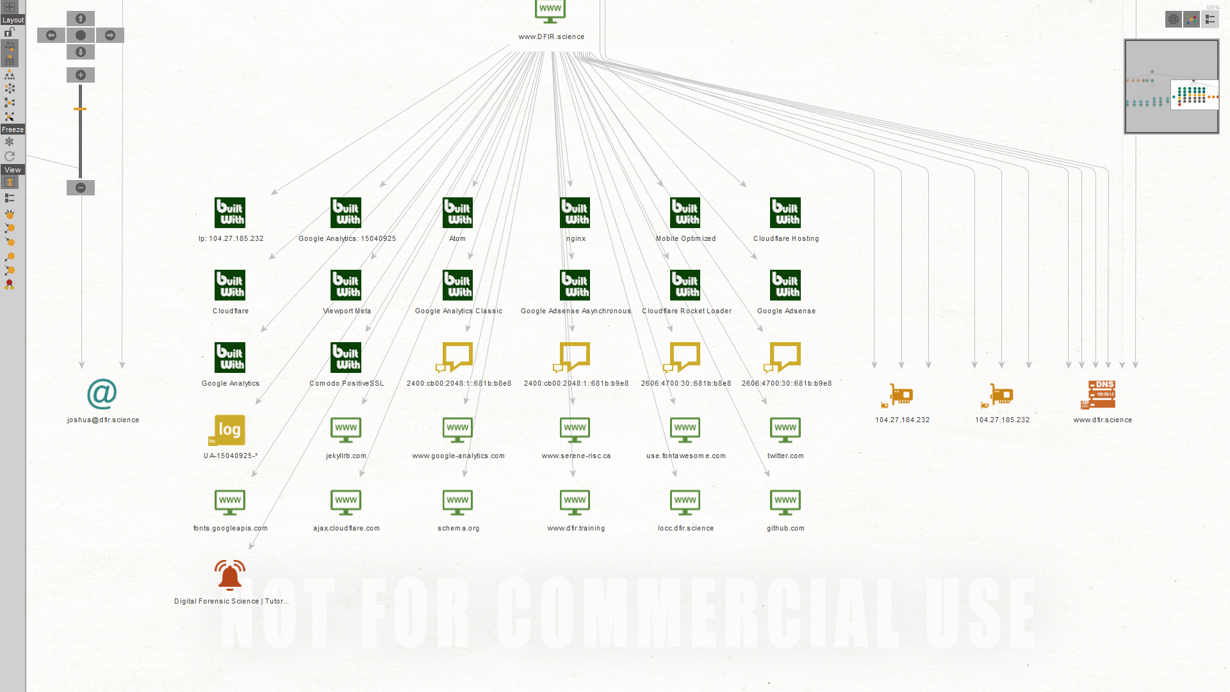

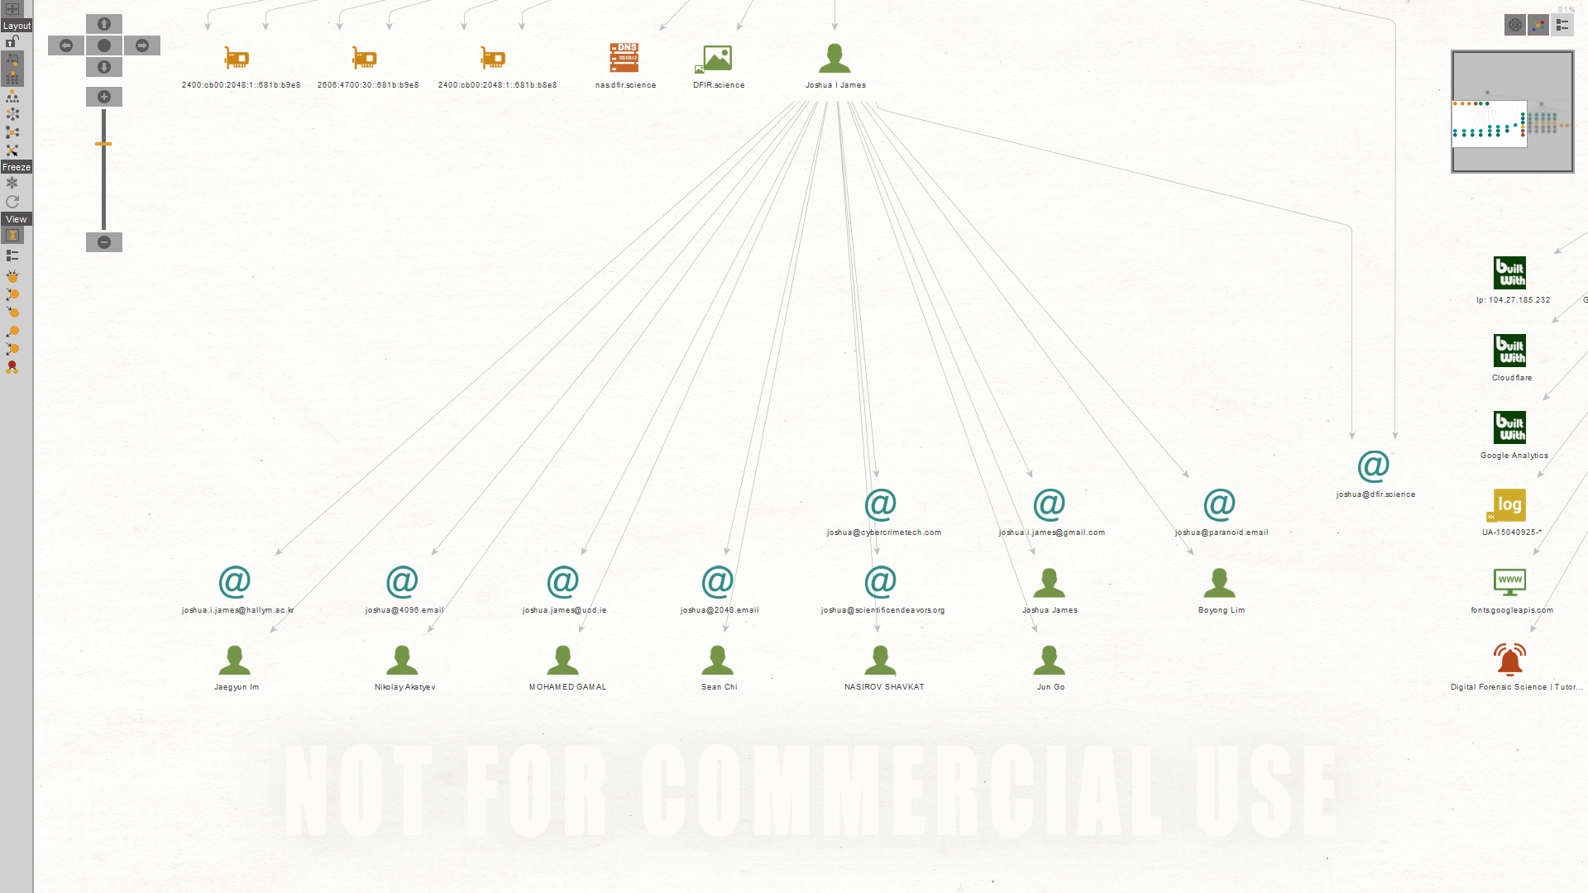

**Thus, by mining for relative data and removing the irrelevant nodes, we have finally zeroed in into these details about the particular domain and the handler.**